Comprehension Questions for Amy Cuddy TED Talk Name: ________________

1. In Cuddy's introduction, she asks the audience to:
a. stand up
b. sit down
c. pay attention to their posture
d. pay attention to her posture

2. Cuddy mentions three research studies that were conducted:
-a doctor's niceness
-a political candidate's face
-emoticons used in negotiations
What was Cuddy's point in mentioning these studies?

3. Place the following 8 key words in order according to Cuddy's talk:

predicts outcomes mood mind/brain non-verbals
judgments interactions hormones communication

(1) ___Mind/brain____ (2) _________________ (3) _________________ (4) _________________

(5) _________________ (6) __interactions_____ (7) _________________ (8) _______________

4. Amy Cuddy is ______ .
a. a social psychologist who studies prejudice, power dynamics, and dominance
b. a Harvard Business School professor
c. a Princeton University advisor for graduate students
d. a social studies teacher at a high school

5. Cuddy mentions a research study with blind people. Why?
To show that both blind and non-blind people _____________ .
a. take on complementary poses
b. show the same non-verbal expressions of powerlessness
c. show the same non-verbal expressions of power and pride

6. a. In the talk, what point was this picture used to illustrate?

b. Do you agree or disagree with that point?

7. Cuddy mentions that in her class, there are two types of students. What are the two types?

(1) ________________________ and (2) _______________________

8. Cuddy said that one big problem that faces many business schools is the "Gender Grade Gap." Explain what this problem is.

9. Cuddy also mentions a research study about putting a pen in your mouth and forcing a smile.
a. What change does doing this cause?

b. What was her purpose in mentioning this study?

10. Testosterone is known as the ___________ .
a. dominance hormone
b. stress hormone
c. growth hormone
d. attention hormone

11. Cortisol is known as the _____________ .
a. dominance hormone
b. stress hormone
c. growth hormone
d. attention hormone

12. When asked to take on an alpha role, power posing can __________ .
a. decrease testosterone and increase cortisol
b. increase both testosterone and cortisol
c. increase testosterone and decrease cortisol

13. Someone who has high levels of cortisol is likely to ________ .
a. not be very stress reactive
b. be very stress reactive

14. In this experiment, participants are asked to spit and gamble. Using the diagram below, explain the experiment, its purpose, and its findings in your own words.

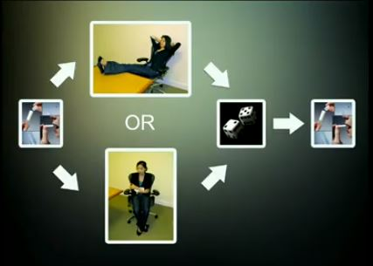 | Procedure:
 | Purpose:
 | Findings:

15. In this experiment, participants are asked to take on a low or high power pose and then undergo a job interview. Using the diagram below, explain the experiment, its purpose, and its findings in your own words.

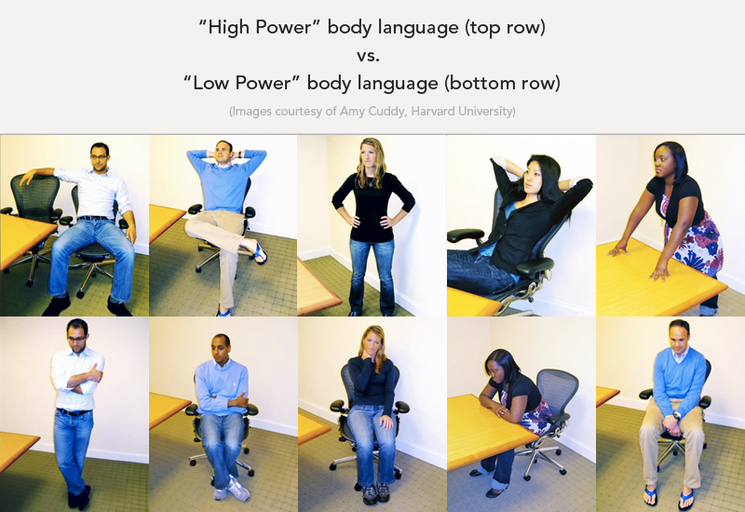 | Procedure:
 | Purpose:
 | Findings:

Personal Story #1:
16. When Cuddy was 19 years old, she was in a terrible _________ ________________ and suffered brain damage. As a result, her _______ dropped 2 points, which made her feel entirely powerless. She was withdrawn from school, but she worked hard and eventually graduated from college. She started graduate school at Princeton University, and the night before her first-year talk, she was so afraid of failing that she called her advisor and told her that ___________________________________ . Her advisor's response was ________________________________________________________________________ .

Personal Story #2:
17. Years later, Cuddy is now a professor at a competitive business school. When a failing student comes into her office, what advice does Cuddy give the student?

What does Cuddy realize about herself at that moment?

