Body Language Vocabulary, Part 1
_____ 1. Life hack  _____ 2. Social scientist/social psychologist  _____ 3. Little tweaks  _____ 4. Chronically  _____ 5. Caricature  _____ 6. Alphas  _____ 7. Stress reactive | - small changes  - a picture or description that ridiculously exaggerates certain parts or defects of a person or thing  - responding intensely to stressful situations  - a tip, trick, or efficient method for doing or managing a common task or problem  - being the most dominant, powerful, or assertive person in a particular group  - continuing for a long time or recurring frequently  G. Someone who studies social behavior and mental processes

Fill in the blanks.
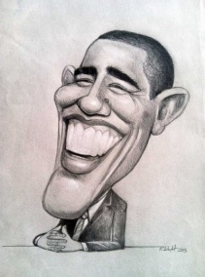
1. My husband says that I don't handle stress very well and that I am very _____________________ . He, in contrast, is usually very calm and rational during emergencies.
2. This ___________________ of the President exaggerates his teeth, chin, and ears.

3. ____________________ #1: use a nail and fork to open a wine bottle
____________________ #2: use a rubber band to twist open bottle caps
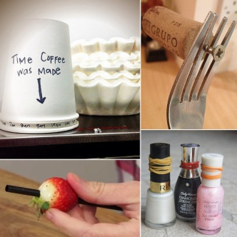

4. Sometimes making big changes in your life can be overwhelming, so start with ______________________ , and it will lead to big changes slowly.

5. Amy Cuddy is a _________________________________ . She studies how people interact with each other, such as how powerful people behave, how powerless people behave, and how we make judgments about other people.

6. My friend suffers from ____________________ fatigue. She often feels tired, even after a good night's sleep. Doctors don't know why. She's had this illness since she was a child.

7. My students are very interesting. There are the _______________ males who dominate the class and are very confident. Then there are the shyer, quieter students who rarely answer questions and sit in the back of class.

Body Language Vocabulary, Part 2
_______ A. being heckled
_______ B. primate
_______ C. assertive
_______ D. inevitable
_______ E. gubernatorial race
_______ F. sweeping judgments
_______ G. wink
_______ H. contemptuous
_______ I. awkward
_______ J. hunching
_______ K. audit
_______ L. posture
_______ M. "standing in social
quicksand"

#1 posture | #2 audit
#3 hunching  #4 primate | #5 awkward
#6 contemptuous | #7 inevitable
#8 assertive | #9 being heckled

